
∑.E.M.
Releases notes v1.04

Releases notes
v1.04
Composant update 3
Bugs 4
Use bootstrap-directional-buttons #76 5
Delete printed document #135 5
Add link to manage task from task list #137 6
Have access to the task activity from the command #125 6
Integrate CRM Lead Management #114 7
Add user information #142 7
Have graphs of quotes and orders #106 8
Optimize change of order of quote and order lines #147 8
Include external elements (or products) in the BOM #141 9

Composant update
- #129 Bump webpack from 5.70.0 to 5.76.2
- #130 Bump guzzlehttp/psr7 from 2.4.3 to 2.5.0
- #132 Composer update for v1.04 :

- Upgrading brick/math (0.10.2 => 0.11.0)
- Upgrading fakerphp/faker (v1.21.0 => v1.22.0)
- Upgrading filp/whoops (2.14.6 => 2.15.2)
- Upgrading graham-campbell/result-type (v1.1.0 => v1.1.1)
- Upgrading guzzlehttp/guzzle (7.5.0 => 7.7.0)
- Upgrading guzzlehttp/promises (1.5.2 => 2.0.0)
- Upgrading guzzlehttp/psr7 (2.4.3 => 2.5.0)
- Locking guzzlehttp/uri-template (v1.0.1)
- Upgrading jeroennoten/laravel-adminlte (v3.8.5 => v3.9.0)
- Upgrading laravel/breeze (v1.18.0 => v1.19.2)
- Upgrading laravel/framework (v9.48.0 => v9.52.8)
- Upgrading laravel/sail (v1.18.1 => v1.22.0)
- Upgrading laravel/serializable-closure (v1.2.2 => v1.3.0)
- Upgrading laravel/tinker (v2.8.0 => v2.8.1)
- Upgrading league/commonmark (2.3.8 => 2.4.0)
- Upgrading league/flysystem (3.12.2 => 3.15.1)
- Locking league/flysystem-local (3.15.0)
- Upgrading livewire/livewire (v2.11.0 => v2.12.3)
- Upgrading maatwebsite/excel (3.1.46 => 3.1.48)
- Upgrading masterminds/html5 (2.7.6 => 2.8.0)
- Upgrading mcamara/laravel-localization (v1.7.0 => V1.8.0)
- Upgrading monolog/monolog (2.8.0 => 2.9.1)
- Upgrading myclabs/deep-copy (1.11.0 => 1.11.1)
- Upgrading nesbot/carbon (2.65.0 => 2.67.0)
- Upgrading nette/utils (v3.2.9 => v4.0.0)
- Upgrading nikic/php-parser (v4.15.3 => v4.15.5)
- Upgrading nunomaduro/termwind (v1.15.0 => v1.15.1)
- Upgrading phpoffice/phpspreadsheet (1.27.0 => 1.28.0)
- Upgrading phpoption/phpoption (1.9.0 => 1.9.1)
- Upgrading phpunit/php-code-coverage (9.2.24 => 9.2.26)
- Upgrading phpunit/phpunit (9.5.28 => 9.6.8)
- Upgrading psr/http-client (1.0.1 => 1.0.2)
- Upgrading psr/http-factory (1.0.1 => 1.0.2)
- Upgrading psr/http-message (1.0.1 => 1.1)
- Upgrading psy/psysh (v0.11.11 => v0.11.18)
- Upgrading ramsey/uuid (4.7.3 => 4.7.4)
- Upgrading sebastian/diff (4.0.4 => 4.0.5)
- Upgrading sebastian/environment (5.1.4 => 5.1.5)
- Upgrading sebastian/recursion-context (4.0.4 => 4.0.5)
- Upgrading sebastian/type (3.2.0 => 3.2.1)
- Upgrading spatie/backtrace (1.2.1 => 1.4.0)
- Upgrading spatie/flare-client-php (1.3.5 => 1.3.6)
- Upgrading spatie/ignition (1.4.3 => 1.8.0)
- Upgrading spatie/laravel-package-tools (1.14.1 => 1.15.0)
- Upgrading symfony/console (v6.2.5 => v6.3.0)
- Upgrading symfony/css-selector (v6.2.5 => v6.3.0)
- Upgrading symfony/deprecation-contracts (v3.2.0 => v3.3.0)
- Upgrading symfony/error-handler (v6.2.5 => v6.3.0)
- Upgrading symfony/event-dispatcher (v6.2.5 => v6.3.0)
- Upgrading symfony/event-dispatcher-contracts (v3.2.0 => v3.3.0)
- Upgrading symfony/finder (v6.2.5 => v6.3.0)
- Upgrading symfony/http-foundation (v6.2.6 => v6.3.0)
- Upgrading symfony/http-kernel (v6.2.6 => v6.3.0)
- Upgrading symfony/mailer (v6.2.5 => v6.3.0)
- Upgrading symfony/mime (v6.2.5 => v6.3.0)
- Locking symfony/polyfill-php83 (v1.27.0)
- Upgrading symfony/process (v6.2.5 => v6.3.0)
- Upgrading symfony/routing (v6.2.5 => v6.3.0)
- Upgrading symfony/service-contracts (v3.2.0 => v3.3.0)
- Upgrading symfony/string (v6.2.5 => v6.3.0)
- Upgrading symfony/translation (v6.2.5 => v6.3.0)
- Upgrading symfony/translation-contracts (v3.2.0 => v3.3.0)
- Upgrading symfony/uid (v6.2.5 => v6.3.0)
Upgrading symfony/var-dumper (v6.2.5 => v6.3.0)
Locking symfony/yaml (v6.3.0)

Bugs
- #138 500 Oops! Internal Server Error on purchases/receipt

Use bootstrap-directional-buttons #76
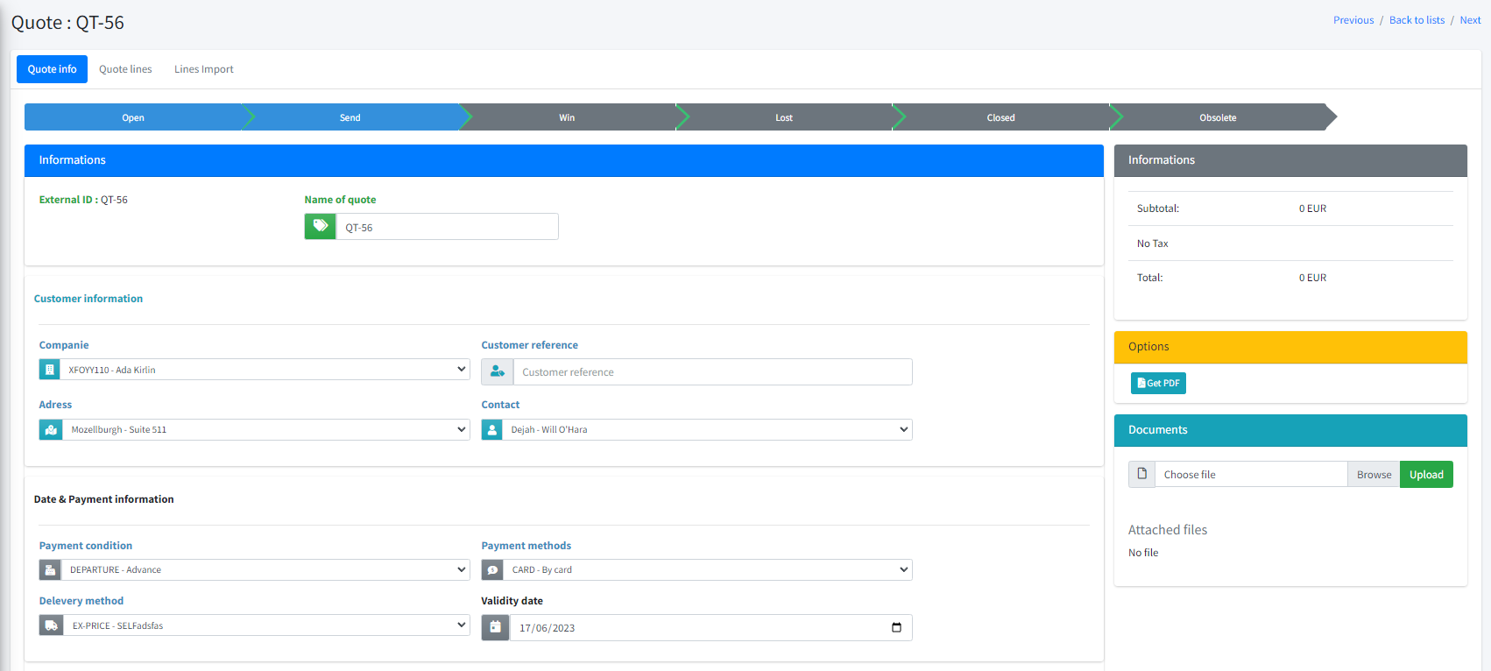

Delete printed document #135
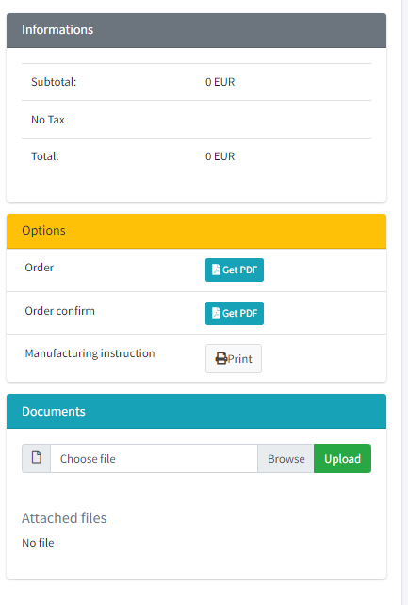

Add link to manage task from task list #137

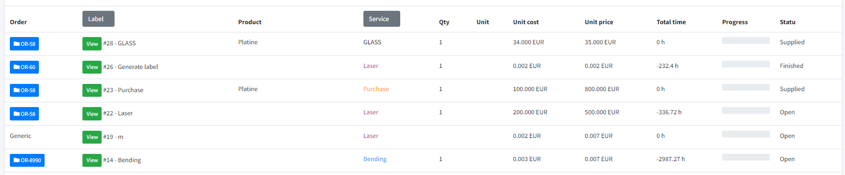

Have access to the task activity from the command #125

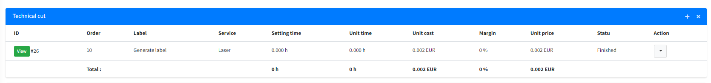

Integrate CRM Lead Management #114

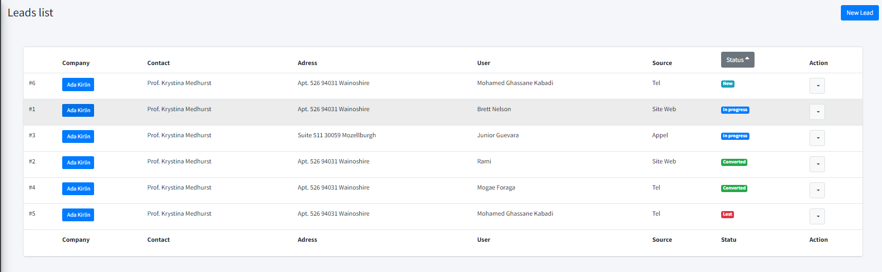

Add user information #142

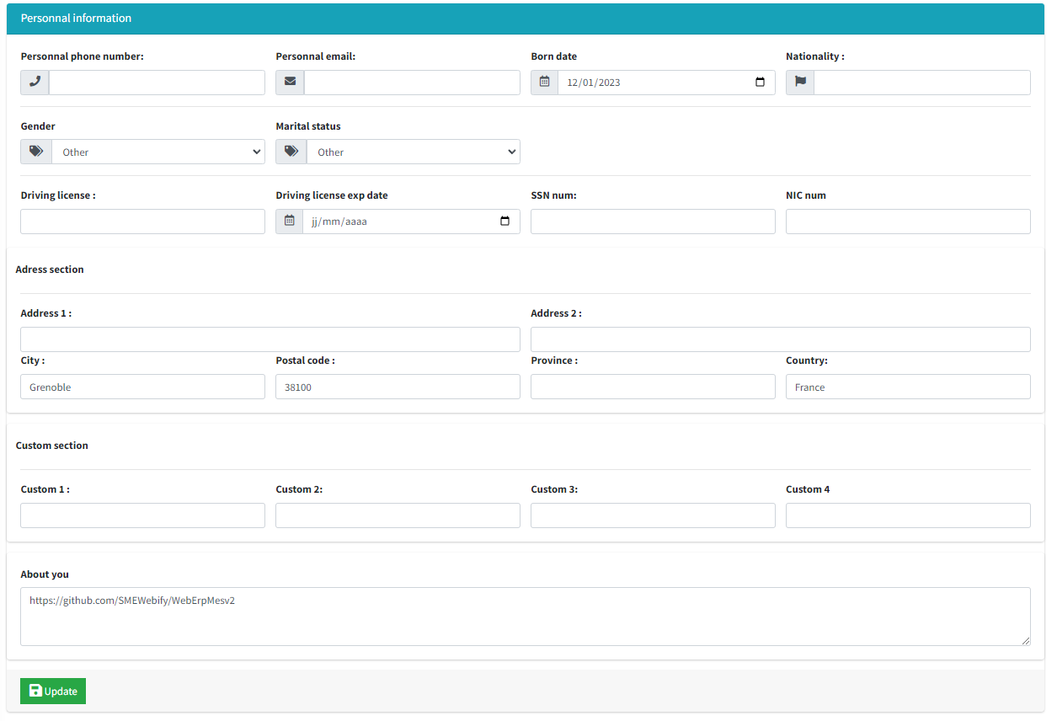

Have graphs of quotes and orders #106

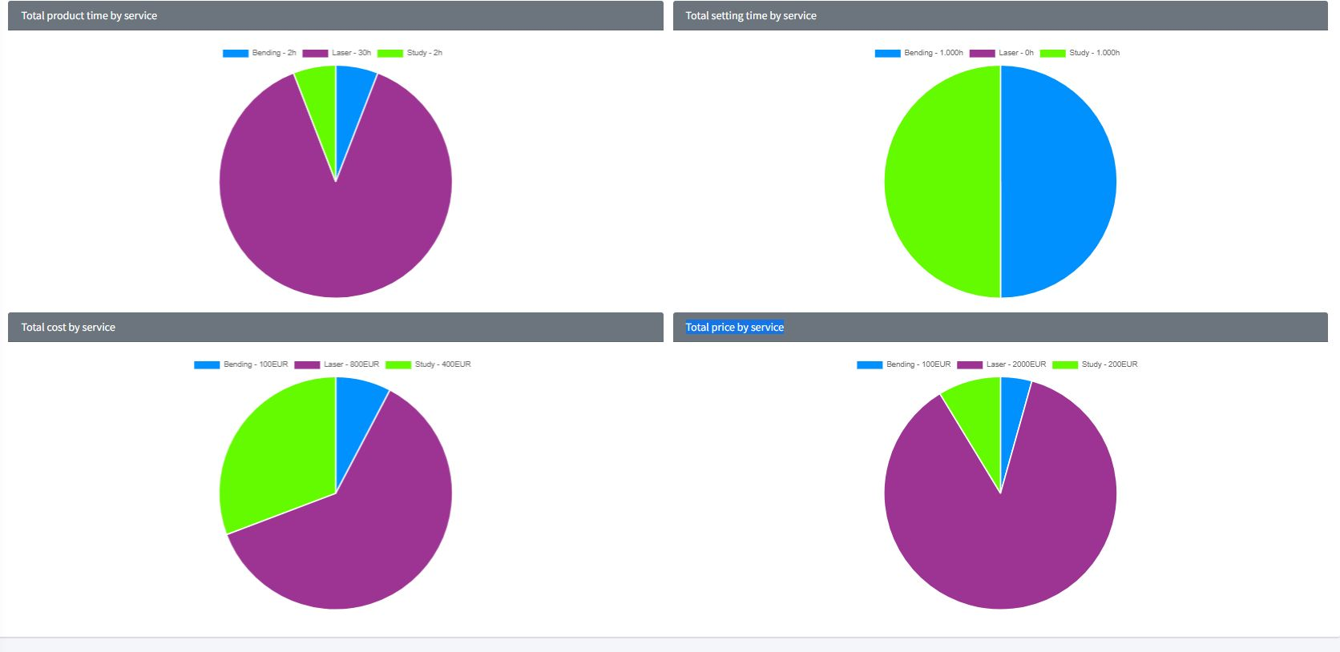

Optimize change of order of quote and order lines #147

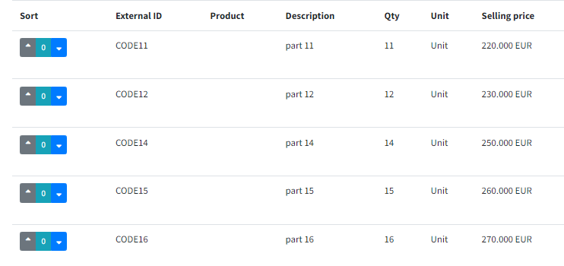

Include external elements (or products) in the BOM #141

